**WHITE GUM VALLEY PRIMARY SCHOOL**

29 Hope Street

White Gum Valley WA 6162

(08) 9435 9600

Whitegumvalley.ps@education.wa.edu.au

**Annual Report 2024**



*White Gum Valley Primary School acknowledges the Whadjuk people of the Noongar*

*nation, who are the Traditional Owners of the Land on which our school stands.*

*We show respect to both past and present Elders and*

*to those who will be Elders in the future.*

*We wish to acknowledge and appreciate the resilience and strength of Noongar people*

*as well as cultural contributions and significance all*

*Aboriginal, Torres Strait Islander and non-Indigenous*

*people bring to our school community.*

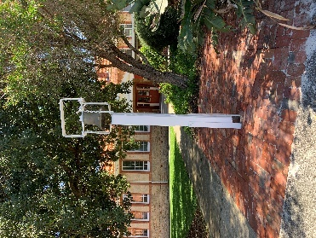

**Contents**___________________________________________

|  |  |
| --- | --- |
| School Overview – Our School-Vision-Purpose………………... | 1 |
| Student Numbers and Characteristics………………………………. | 2 |
| Workforce Composition…………………………………………………… | 3 |
| Leadership Distribution Structure……………………………………. | 4 |
| Student Attendance Data……………………………….................... | 5-6 |
| Student Achievement and Progress…………………………………. | 7-10 |
| Post School Destination…………………………………………………… | 11 |
| School Income by Funding Source……………………………………. | 12-14 |
| School Priorities……………………………………………………………….. | 15-19 |
| 2023-2025 Business Plan……………………………....................... | 20-21 |
| School Partnerships and School Involvement…………………… | 22-25 |
| Conclusion……………………………………………………………………….. | 25 |

**School Overview____________________________________________** 1

OUR SCHOOL

White Gum Valley Primary School is a community of learners striving for excellence in an environment of care, support and cooperation.

The school is attractively situated in White Gum Valley, within close proximity to the port city of Fremantle.

White Gum Valley was once an important meeting place for local Aboriginal people. The school was established in 1901 and much of its original heritage structure remains. The school displays a lot of its rich history in the main administration area.

The school consists of the main Pre-Primary – Year 6 site on Hope Street and the off-site Hazel Orme Community Kindergarten located on Samson Street.

The school also has an onsite Playgroup building used for 0–3-year-olds. We have a provision for before and after school care.

Our care extends to a pastoral care program that promotes positive behaviour management and emotional development using the Positive Behaviour in Schools Program (PBS).

The school also has in place a Reconciliation Action Plan (RAP) that helps guide our planning.

Our support from other agencies includes MANNA Inc, Foodbank, Ed-Connect Volunteers in Schools Inc and a Speech program through a university and Speech Centre collaboration.

Our school P&C Association is actively involved with the school and undertake many community fundraising events. The Association also run the Canteen and Uniform Service. They have established a range of sub-committees and individual class representatives.

Our School Board plays an important role in assisting set strategic directions and maintain our Business Plan objectives.

Further information about our wonderful school can be found on our website at whitegumvalley.wa.edu.au.

OUR VISION

White Gum Valley Primary School supports:

* Students to grow academically, socially, emotionally, physically and creatively in a positive, enjoyable and inclusive learning environment.
* Students being empowered to meet the challenges of a rapidly evolving world.
* A safe and supportive learning and working environments for all students and staff.
* Our students to demonstrate respect for themselves, others, the school and the wider community.
* The recognition, acknowledgement and celebration of diversity in our community.
* The valuable contributions of our community to support student learning.

OUR PURPOSE

At White Gum Valley Primary School, we aim to develop:

* Students to grow academically, socially, emotionally, physically and creatively in a positive, enjoyable and inclusive learning environment.
* Students being empowered to meet the challenges of a rapidly evolving world.
* A safe and supportive learning and working environment for all students and staff.

**Student Numbers and Characteristics 2024_______________________** 2

**Student Numbers Characteristics**

**Numbers. Numbers.**

|  |  |  |  |  |  |  |  |  |  |  |  |  |  |  |  |  |  |  |  |  |  |  |  |  |  |  |  |  |  |  |  |  |  |  |  |  |  |  |  |  |  |  |  |  |  |  |  |  |  |  |  |  |  |  |  |  |  |  |  |  |  |  |  |  |  |  |  |  |  |  |  |  |  |  |  |  |  |  |  |  |  |  |  |  |  |  |  |  |  |  |  |  |  |  |  |  |  |  |  |  |  |  |  |  |  |  |  |  |  |  |  |
| --- | --- | --- | --- | --- | --- | --- | --- | --- | --- | --- | --- | --- | --- | --- | --- | --- | --- | --- | --- | --- | --- | --- | --- | --- | --- | --- | --- | --- | --- | --- | --- | --- | --- | --- | --- | --- | --- | --- | --- | --- | --- | --- | --- | --- | --- | --- | --- | --- | --- | --- | --- | --- | --- | --- | --- | --- | --- | --- | --- | --- | --- | --- | --- | --- | --- | --- | --- | --- | --- | --- | --- | --- | --- | --- | --- | --- | --- | --- | --- | --- | --- | --- | --- | --- | --- | --- | --- | --- | --- | --- | --- | --- | --- | --- | --- | --- | --- | --- | --- | --- | --- | --- | --- | --- | --- | --- | --- | --- | --- | --- | --- |
| |  |  |  |  |  |  |  |  | | --- | --- | --- | --- | --- | --- | --- | --- | |  | |  | | | | |  | | |  | | --- | | **2020** | | |  | | --- | | **2021** | | |  | | --- | | **2022** | | |  | | --- | | **2023** | | |  | | --- | | **2024** | |  | |  | |  |  | | --- | --- | |  |  | |  | Primary (Excluding Kin) | | |  |  |  | | --- | --- | --- | |  |  |  | |  | 248 |  | | |  |  |  | | --- | --- | --- | |  |  |  | |  | 278 |  | | |  |  |  | | --- | --- | --- | |  |  |  | |  | 287 |  | | |  |  |  | | --- | --- | --- | |  |  |  | |  | 259 |  | | |  |  |  | | --- | --- | --- | |  |  |  | |  | 258 |  | |  | | |  |  | | --- | --- | |  |  | |  | Total | | |  |  |  | | --- | --- | --- | |  |  |  | |  | 248 |  | | |  |  |  | | --- | --- | --- | |  |  |  | |  | 278 |  | | |  |  |  | | --- | --- | --- | |  |  |  | |  | 287 |  | | |  |  |  | | --- | --- | --- | |  |  |  | |  | 259 |  | | |  |  |  | | --- | --- | --- | |  |  |  | |  | 258 |  | |  | |  |  |  |  |  |  |  | |  |  |

**Student Characteristics**

|  |  |  |
| --- | --- | --- |
|  | **2024 FTE** | **2023 FTE** |
| Aboriginality | 8 | 14 |
| Disability | 12 | 29 |
| English as an Additional language or Dialect | 8 | 13 |

**Student Numbers**

|  |  |  |  |
| --- | --- | --- | --- |
|  | **2024** | **2023** | **2022** |
| Total | 258 | 259 | 283 |
| Pre-Primary | 42 | 29 | 39 |
| Year 1 | 31 | 33 | 46 |
| Year 2 | 30 | 44 | 33 |
| Year 3 | 48 | 32 | 42 |
| Year 4 | 30 | 41 | 42 |
| Year 5 | 38 | 38 | 45 |
| Year 6 | 39 | 42 | 36 |

**Workforce Composition______________________________________** 3

Student numbers reached 258 in Semester Two 2024 and our numbers for Semester One 2025 are currently 255.

Our forecast for 2026 based on numbers enrolled at the Hazel Orme Community Kindergarten and at Fremantle PS is for 273 students across the school, with approximately 3% of our students from an Aboriginal or Torres Strait Islander background.

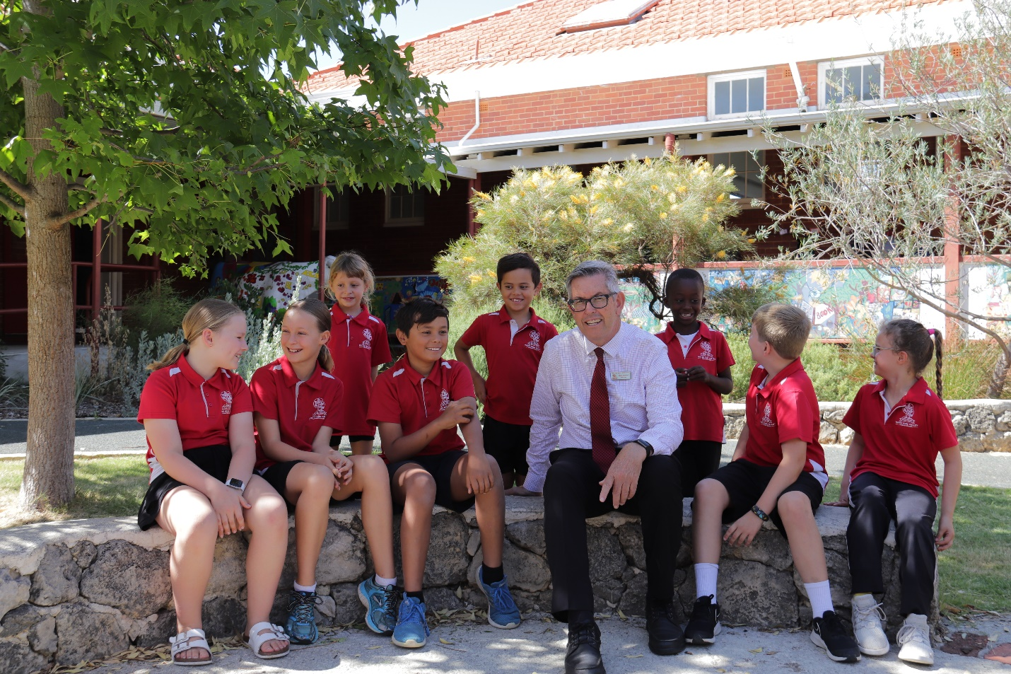

The Student Services team consisting of our Chaplain, Psychologist, AIEO, Mental Health and Learning Support coordinator work closely with the students. Other support services included extra Education Assistant time taken from our school budget.

Coaches for Teaching for Impact (under the Quality Teaching Strategy) and Literacy were appointed for the year.

**Workforce Composition 2024**

|  |  |  |  |
| --- | --- | --- | --- |
| **Position** |  | **Number Of Staff** | **FTE** |
| Principal |  | 1 | 1.0 |
| Deputy Principal |  | 1 | 1.0 |
| Level 3 Teachers |  | 1 | 1.0 |
| Other Teaching Staff |  | 21 | 14.5 |
| Other Non-Teaching Staff |  | 11 | 7.8 |
| Instructional |  | 2 | 0.2 |
| Clerical/Administrative |  | 3 | 2.6 |
| Gardening/Maintenance |  | 1 | 0.4 |
| Total | | 41 | 28.5 |

All teaching staff met the professional requirements to teach in Western Australian schools and can be found on the public register of teachers on the Teacher’s Registration Board of Western Australia.



Our school promotes leadership opportunities for staff through a range of committees, Professional Learning Committees [PLC], Phase of Learning teams and School Leadership team structures.

In 2024 two staff completed an 18-month Future Leaders program through the Fremantle-Cockburn Network and our Deputy Principal won a position at a neighbouring school. A new MCS was also appointed through a selection process. Currently, two of our Education Assistants are undertaking teacher training.

**Student Attendance Data___________________________________________________________** 5

|  |
| --- |
|  |
| |  |  |  |  | | --- | --- | --- | --- | |  | **Semester 2** | **Semester 1** | **Overall** | | **Attendance Rate** | 88.5% | 91.8% | 90.15% | | **Authorised Absence** | 73% | 74% | 73.5% | | **Unauthorised Absence** | 27% | 26% | 26.5% | | **Regular student Attendance** | 56.7% | 75.5% | 66.1% | | **Indicated Risk Attendance** | 31.8% | 18.7% | 25.25% | | **Moderated Risk Attendance** | 8.0% | 5% | 6.5% | | **Severe Risk Attendance** | 6.5% | 0.8% | 3% | | **PPR Attendance** | 90.1% | 92.2% | 91.15% | | **Y01 Attendance** | 86.2% | 87.7% | 86.95% | | **Y02 Attendance** | 90.1% | 94.9% | 92.5% | | **Y03 Attendance** | 90.6% | 94.1% | 92.35% | | **Y04 Attendance** | 87.5% | 90.3% | 88.9% | | **Y05 Attendance** | 88.8% | 91.6% | 90.2% | | **Y06 Attendance** | 85.6% | 90.8% | 88.2.% | |  |  |  |  | | **2024** | **2023** | **2022** | **2021** | | 90.15% | 89.99% | 88.2% | 91.9% | |
| **Analysis and impact of evidence** |
| Overall attendance improved from 2023 with Semester 1 showing higher rates than Semester 2.  The authorised attendance rate improved from 2023.  Regular attendance reflected 2023. The indicated risk level rose slightly and the number of students in the severe risk area dropped.  Families can communicate absences to the school via email, an online absence form placed on the website and through a phone call to the school office. Regular articles are written and published to families promoting regular attendance, via our fortnightly newsletter.  For families who are contemplating a holiday in term time, we ask that they commit to undertake learning activities to reduce impact on student outcomes, including-   * Make a record or diary of their holiday in a diary or memory box. * Do some real-life educational activities such as map reading, math, literacy, languages, geography, history, science according to their situation. * Complete a research project on the holiday destination. * Complete a book diary with photos, drawings, sketches and student writing.   We promote and celebrate positive school attendance, including:   * The class with the best weekly attendance is celebrated and asked to host the indigenous players’ signed guernsey that had been donated by the Fremantle Dockers football club. |

|  |
| --- |
| **Describe how non-attendance is managed by the school** |
| We follow up on absences and with families of students who have a moderate or severe risk of attendance:   * We adhere to departmental policies and procedures. * Absences followed up through termly INTEGRIS letters to parents requesting information. * Informal notes are sent home from teachers asking for reasons for unexplained absences. * Letters sent to families of students with a moderate or severe at-risk attendance rate. * Our Aboriginal Islander Education Officer (AIEO) supports Aboriginal students and families by providing 1:1 student sessions, having discussions with parents/carers and assisting with welfare needs as they arise. * Our school Chaplain supports students and their families by providing 1:1 student sessions, having discussions with parents/carers and assisting with welfare needs as they arise. * Meetings with families of students with a moderate or severe at-risk attendance rate after a second attendance letter has been sent. * Attendance improvement plans are created, in conjunction with families of students with severe at-risk attendance rates. * Home visits are undertaken by the Deputy Principal, Chaplain or AIEO with the Attendance officer at the South Metropolitan Office. |

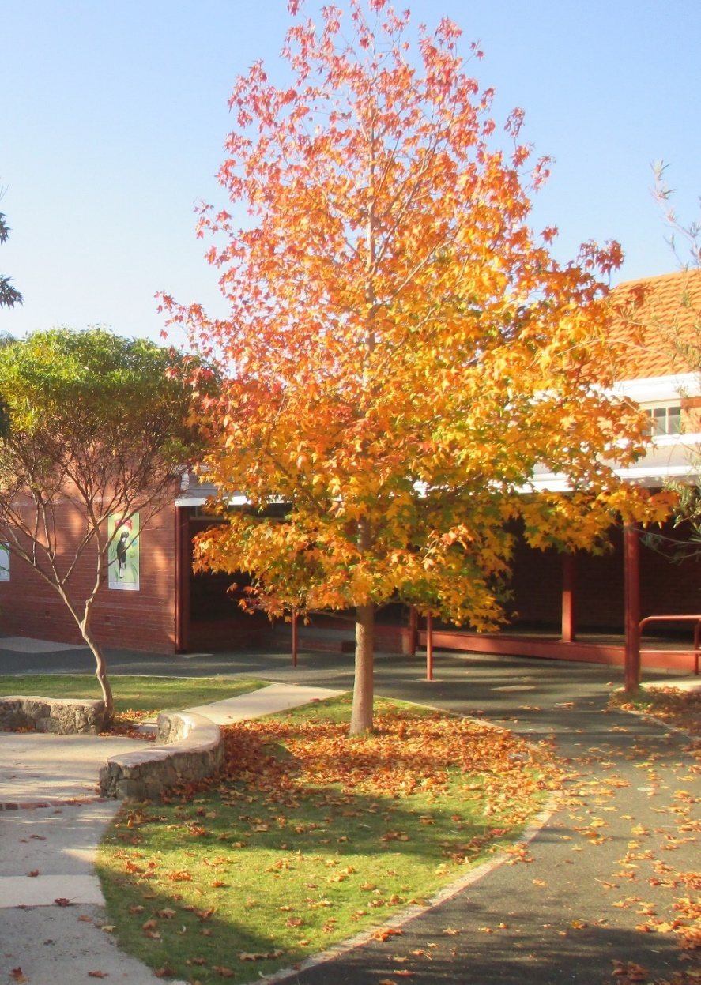

**Student Achievement and Progress Data**

___________________________________________________________________________________________ 7

**In 2024, we followed the goals of our 2023-2025 Business plan. In this plan, we identified Student Achievement and Progress Targets that we would like to achieve over the course of the 3 years.**

In 2024, a range of formalised testing was used to complement class progress testing.

* NAPLAN testing for March – Year 3 and Year 5.
* PATS testing across Maths, Reading, Science and Grammar/Punctuation – Years 3-6
* MOTIF DIST assessment for February and August – Pre-primary – Year 2.
* On Entry testing for February – Pre-primary – Year 1 (selected cohort).
* DiBELS testing for Year 1 and 2.

**NAPLAN (National Assessment Program – Literacy and Numeracy)**

**In 2024, the way in which individual student achievement was reported changed. Students were reported as meeting one of 4 proficiency levels:**

* **Exceeding**: the student’s result exceeds expectations at the time of testing.
* **Strong**: the student’s result meets challenging but reasonable expectations at the time of testing.
* **Developing**: the student’s result indicates that they are working towards expectations at the time of testing.
* **Needs additional support**: the student’s result indicates that they are not achieving the learning outcomes that are expected at the time of testing. They are likely to need additional support to progress satisfactorily.

(<https://www.nap.edu.au/naplan/results-and-reports/proficiency-level-descriptions>, 2024)

|  |  |
| --- | --- |
| **Business Plan Targets** | **Achievement against the Targets** |
| The % of students reported as reaching ‘Exceeding’ or ‘Strong’ levels of achievement will track to be similar to ‘like schools’ each year in **Reading, Writing and Language Conventions (LC).** | **Year 3**  **Reading** – 75% of students met ‘exceeding’ or ‘strong’ achievement levels  Like schools – 82%  **Writing** – 82% of students met ‘exceeding’ or ‘strong’ achievement levels  Like Schools – 92%  **Grammar (LC)** –55% of students met ‘exceeding’ or ‘strong’ achievement levels  Like Schools – 73%  **Spelling (LC)** - 62% of students met ‘exceeding’ or ‘strong’ achievement levels  Like schools – 76% |
| **Year 5**  **Reading** - 92% of students met ‘exceeding’ or ‘strong’ achievement levels  Like schools – 85%  **Writing** – 79% of students met ‘exceeding’ or ‘strong’ achievement levels  Like schools – 81%  **Grammar (LC)** – 88% of students met ‘exceeding’ or ‘strong’ achievement levels  Like schools – not available  **Spelling** **(LC)** - 89% of students met ‘exceeding’ or ‘strong’ achievement levels  Like schools – 80% |
| The % of students making high and very high levels of progress from Year 3 to Year 5 will track to be similar to ‘like schools’ each year in **Reading, Writing and Language Conventions (LC).** | **This data is not available until 2025 due to changes in NAPLAN Reporting.** |
| The % of students reported as reaching Exceeding or Strong levels of achievement will track to be similar to ‘like schools’ each year in **Numeracy**. |
| The % of students making high and very high levels of progress from Year 3 to Year 5 will track to be similar to ‘like schools’ each year in **Numeracy**. |

**PAT (Progress Attainment Tests)**

We use the ACER Progressive Attainment Tests to track students on a year to year basis. Students complete the assessments twice a year with student progress being monitored and tracked. Students are reported as reaching a stanine level (Stanine stands **for standard nine** and indicates nine statistical units from a scale of 1 to 9). Stanine 4 indicates a student is reaching the expected level for their chronological age. We have set an inspirational goal across all subjects assessed using the PATS platform that students will achieve stanine 5 or above. These assessments are norm referenced in September meaning that students appear to be below their expected level in Semester 1.

|  |  |
| --- | --- |
| **Business Plan Target** | **Achievement against the Target** |
| **Progressive Attainment Tests (PATS)**  At least 70% of students, in Years 3 - 6, will achieve Stanine 5 or above in PATs Reading, Grammar and Punctuation, Numeracy and Science by the end of each year. | **Semester 1**  **Reading** – 73%  **Grammar and Punctuation** – 88%  **Numeracy** – 57%  **Science** – 69%  **Semester 2**  **Reading** – Avg of 74% across Years 2 -6  **Grammar And Punctuation** – Avg of 87% across Years 3 -6  **Numeracy** – Avg of 78 % across Years 3 -6  **Science -** Avg of 73 % across Years 3 -6 |

**Motif DiST Pre-primary to Year 3**

MOTIF is a set of tests that allow teachers to trouble shoot literacy difficulties in students. With an evidence base to support the tests, it was developed by several professors at Macquarie University. It provides a number of tests that allow teachers to learn more about students’ knowledge and understanding in the area of Sounds, Non words and Irregular Words. We conducted the tests in February and again at the end of Term 3 to check for progress made. From the tests conducted in February, teachers were able to identify students who required extra support as well as identifying common errors for the students to rectify. The tests conducted in Term 3 was an opportunity for teachers to check the impact of their teaching as well as further identifying students who needed closer monitoring in 2024.

**DiST-s out of 32 (sounds)** This test is conducted with students from Pre-primary to Year 2.

**DiST –n out of 74 (non words)** This test is conducted with students from Year 1 to Year 3

**DiST-I out of 74 (Irregular words)** This test is conducted with students from Year 2 and Year 3

|  |
| --- |
| **Business Plan Target** |
| **Diagnostic Spelling Tests (DiST)**  To increase the % of students achieving above average and well above average results in each of the tests across Pre-primary to Year 3 from 2023-2025 |
| **Summary: Strong Mid-Year Gains in Literacy Outcomes**  The 2024 mid-year DiST data reflects exceptional progress toward our business goal of increasing above average performance in literacy assessments from Pre-primary to Year 3.   * **Performance Boost**: Across the board, students are showing notable increases in above average and well above average scores, particularly in DiSTn (nonwords), which assesses phonics and decoding skills. Year 2 and Year 3 students demonstrated significant gains, with more than half now performing above expected levels. * **Reduced Risk**: Equally encouraging is the sharp reduction in students at high or some risk, especially in Pre-primary and Year 1. This shift highlights the impact of targeted teaching strategies and early intervention.   Together, these trends showcase the positive trajectory of student learning and affirm the effectiveness of our literacy initiatives and evidence-based instruction. We are well on track to achieving our 2023–2025 targets. |
|  |

**On Entry PP-Year 1 (selected cohort)**

Our school undertakes the Education Department OnEntry testing program in Pre-primary, yearly. The information generated from the one-on-one testing in Reading, Writing, Speaking and Listening and Numeracy helps identify the learning needs of individual students and areas for teaching by teachers. There are four modules for each subject and responses are then calibrated into bands and given a percentage. At White Gum Valley PS, this testing in 2024 included students in Years One as the scoring leads into NAPLAN data available in Year 3. Individual information for OnEntry was made available to parents.

OnEntry assessments are a diagnostic tool for our teachers in Pre-primary and Year 1. The assessments do not have a pass or fail or a desirable standard.

As a way of monitoring progress, this testing from Pre-primary is linked to our monitoring of students through to their first NAPLAN testing in Year 3. A monitoring and tracking document was in place for our staff. Staff met to look through the data and student responses as part of Disciplined Dialogue meetings to put planned actions in place. These meetings helped to outline approaches for assessing student needs for class programming as well as meeting the needs of individual students.

|  |  |
| --- | --- |
| **Business Plan Target** | **Achievement against the Target** |
| **On-Entry Testing**  At least 70% of students will make moderate or above average progress in Reading and Numeracy from PP to Year 1 in On Entry testing. | **Reading** – 62.5% making moderate or above progress from Pp.  **Numeracy** – 41.7% making moderate or above progress from Pp. |

**DIBELS** ® (**Dynamic Indicators of Basic Early Literacy Skills**)

OnEntry is mandated in Pre-primary and is optional for Years 1 and 2. A decision was made in 2023 to assess only Pre-primary and Year 1 using this suite of assessments. To ensure that students in Year 2 were monitored, a number of assessments were carried out in addition to teacher judgements and common assessment tasks. Students in Year 2 were assessed using **DIBELS** ® (**Dynamic Indicators of Basic Early Literacy Skills**), which is a set of procedures and measures for assessing the acquisition of literacy skills. Students are assessed more specifically with their oral reading fluency, accuracy and comprehension. All students are measured against a scale of risk;

**Negligible risk**- requiring usual classroom teaching (this is where we what we want our students to achieve).

**Minimal risk** – requiring core support

**Some risk** – requiring strategic support

**At risk** – requiring intensive support.

Our aspirational goal is for all students to be identified as being at negligible risk.

|  |  |
| --- | --- |
| **Business Plan Target** | **Achievement against the Target** |
| **Dynamic Indicators of Basic Early Literacy Skills (DIBELS).**  To increase the % of students being identified as being at minimal and negligible risk in Year 2 from 2023 through to 2025. | **ORF (Oral Reading Fluency – This is a measure of speed at which they read words correctly)**  From Term 1 to Term 4 - the % of students at minimal or negligible risk decreased by 12%.  **ORF Accuracy (This is a measure of how accurate the students are with what they read)**  From Term 1 to Term 4 - the % of students moving from high risk to minimal or negligible risk increased by 80%.  **Maze – Measure of Reading Comprehension**  From Term 1 to Term 4 - the % of students moving from high risk to minimal or negligible risk increased by 7% |

**Next steps for all assessments...**

* Identification of students who haven’t made expected progress will be shared with individual teachers.
* Teachers carry out a Disciplined Dialogue Process, sharing action planning with the Deputy Principal. This plan is then monitored over the year.
* Continuation of Monitoring and Tracking document
* Analysis against progress made by individual students in the Letters and Sounds Program (All tracking booklets are completed by Week 6 of Term 4).
* Use of Elastik, a software tool introduced in 2024 that is used to monitor and analyse data collected with the intention of providing point of error teaching for individuals, groups and whole class instruction where identified.

In 2025, our testing schedule to track and monitor student achievement and progress will include;

* NAPLAN testing for Years 3 and 5.
* On Entry for Pre-primary and identified students from Year One.
* PATS testing for Years 2-6.
* MOTIF DIST for Pre-primary – Year 3.
* Dynamic Indicators of Basic Early Literacy Skills (DIBELS) – Year 1 and 2
* Brightpath for Writing across the whole school.
* Placement testing: ‘Letters and Sounds’, Speech Therapy, Spelling Mastery and Sounds Write (for identified students).

**Post School Destination**____________________________________ 11

2025 school destinations of our 2024 Year 6 group – Total Number: 35

Of these students, 69% enrolled at Government High Schools, many in the merit select courses that involved an application, testing and interview.

|  |  |
| --- | --- |
| **Destination** | **Number** |
| John Curtin College | 14 |
| Fremantle College | 10 |
| CBC | 3 |
| PLC | 1 |
| Seton College | 7 |

Transition opportunities were provided by all of the secondary schools during Term 4, 2024. Feedback from the students regarding these transition events was that they found the opportunity to become familiar with the surroundings and programs very valuable and went a long way to help reduce anxiety.

Anecdotal high school feedback by students who returned to the school during the year included: learn early about management, be prepared for lessons, seek help if you need it and take advantage of all the clubs and other offerings the school may have to help meet new friends with similar interests.

**School Income by Funding Source_____________________________** 12

**Finance**

The school finance position was very positive at the end of 2024.

Voluntary Contributions closely met our budget estimate with 88% of families contributing to our Voluntary Contributions scheme, building on the 86% in 2023.

The school received $30,209.00 for leasing out school facilities to Horizons Out of Hours Care Service and for external Music tuition. This paid for our Speech Therapy initiative, School Volunteer program [Ed Connect] and provided resources for our learning programs supporting individual students.

Donations and funds generated from the P&C came to $25071.00

Total funds available for 2024 totalled $3,917,195.00 and total expenditure amounted to $3,556,193.00

The highest areas of spending were in the areas of Buildings/Property/Equipment/Maintenance and Curriculum/Student Services.

An amount of $94,836.00, was transferred to our Reserve accounts in 2024. The total amount of reserves was $438,817.98. [Funds to come out in Term 1 2025 include $198,000 for our covered assembly area extension, $17,000 for a roof cover and sink outside junior classes and our entry statement.] Funds are allocated yearly to build reserves for building improvements, computer replacement, updating equipment and repairs.

The general fund carry-over into 2025 was $100,701.00. This is similar to 2024.

**Resources**

GRANTS: During 2023 the school was successful in applying for and obtaining grants for our School Chaplain, Mental Health Co-ordinator, AERO language testing trial, Quality Teaching Strategy funding for cross-school visits, puppet incursion, 27.5 KW of solar panels and expanding our covered assembly area.

DEPARTMENT FUNDS: Funds generated through student enrolment enabled the school to employ extra Education Assistant time in the early years, support for our Letters and Sounds program, coaches from amongst staff to lead Literacy and the Quality Teaching Strategy initiative, provide extra gardening time, release time for staff to work on special projects, appointment of a Technology teacher and Speech pathologists as well as releasing staff for professional learning opportunities. Release time for staff to collaborate in professional curriculum teams has been very useful in promoting whole school programs and processes. School funds were also allocated to student and teacher curriculum resources, library resources, grounds improvements, student computers and new furniture for classrooms.

**Major Projects Commenced/Completed:**

* Entrance Statement. Enlarging and enclosing our Covered Assembly Area. Roof and sink outside junior classes.
* Various programs including Bright path, Spelling Mastery, Sounds-Write, Butterfly Body-Bright and Lighthouse Maths.
* New student furniture.

School Financial Summary-December 2024.











**SCHOOL PRIORITIES**________________________________________ 15

These have been linked to the six domains of the School Review Standard and also our School Business Plan.

Relationships and Partnerships.

Communication: The school has put in place various forms of communication with families throughout 2024.These included:

* Information home via CONNECT and email for newsletters and notes.
* Fortnightly newsletters.
* Individual class CONNECT notes.
* Curriculum newsletter sent out at the start of each term outlining what the class teacher/specialist will be covering.
* Semester Reports.
* Opportunities at the start of Term 3 for parent interviews via an early close afternoon.
* Class run assemblies.
* Open evening in Term 3 which included musical items.
* Maths problem solving workshop.
* Welcome Picnic at the start of the year.
* Incursions/excursions/sporting carnivals.

Cultural responsiveness-All staff have completed the three yearly cultural standards awareness/framework professional learning and participated in extra content during school development days. The school updated its [RAP] Reconciliation Action Plan late 2024, early 2025. A relationship with a local elder was established. Two projects were commenced: tiled signage around the school and the design and production of a school Leavers shirt for 2025.Our Aboriginal and Torres Strait Islander Education officer [AIEO] worked with staff to acknowledge various important dates during the year, some of which featured in school assemblies. The school continued to be part of the Reconciliation Growth committee Connect group along with Reconciliation WA, Reconciliation Australia, ‘Racism No way’ and the Education Department Aboriginal Teaching and Learning Connect group.Our librarian added to a quite substantial collection of resources and fiction books.

Staff Communication was enhanced through the use of the TEAMS channel to share documents across all learning areas and make alterations in real time to inform planning.

During 2024 our Positive Behaviour in Schools plan [PBS] was reviewed and refined. Visuals and common language form part of our whole-school approach to behaviour management.

The National School Satisfaction Survey last completed in 2022/3 will be undertaken again in 2025/6.

The school completed a full year of the Butterfly Body Bright program which focused on how we view our body image. It was a wonderful addition to our Health program.

Leadership.

**Student Leadership** -

In 2023, as part of our PBS program, representatives from years 3-5 were elected to meet with a designated staff member to provide feedback and suggestions on various topics including ROS rewards and structuring wellbeing activities. These meetings held each term provided an avenue for student voice.

Other leadership opportunities included: faction captains, student councillors, ‘Your Move’ team representatives, flag flying team, Buddy program across classes and a ‘GRIT’ program run by the School Chaplain.

**Staff Leadership** - The school has in place a Leadership team that meets weekly, along with phase of learning teams, curriculum committees and other committees that focus around management areas like Finance and OSH.

The Student Services team met regularly, bringing together our Chaplain, AIEO, psychologist, Learning Support coordinator, Mental Health coordinator and various staff.

Two staff were chosen to be part of the Fremantle Cockburn Emerging leaders initiative undertaking a range of leadership professional learning across 2023/4. Part of the initiative involved delivering projects that can be implemented in the school to further our focus areas.

The school provided release time and professional development opportunities to enhance staff skill development. This was particularly useful for framing operational plans and developing policy/guidelines documentation. A literacy specialist worked with staff providing support. A QTS [teaching for Impact] coach was also appointed to promote the growth of teaching skills. Our goal is to have formalised instructional strategies embedded so as to support low variability and high consistency of teaching practices for all of the staffing team.

In 2024 the school continued to promote staff to act as mentors through undertaking peer classroom observations, moderation of student work and regular meetings to discuss student progress via disciplined dialogue sessions. All staff were involved with the process.

Other leadership opportunities saw staff take on roles with the School Board, Inclusivity group, Positive Behaviour in Schools team [PBS], [ECE] Early Childhood team developing the [NQS] National Quality Standard as well as Finance and Well- Being committees.

Our deputy was given the opportunity to lead at another local school which provided an opportunity for an aspirant to undertake the role during the year.

New leadership was established in the office area with the appointment of a Manager Corporate Services. [MCS]

Quality Teaching.

The staff as a whole school engaged in a number of programs that ran across several year levels as a result of reviewing student data over time.

In 2024 the programs in place included: Brightpath Writing, Letters and Sounds, Sounds Write, Lighthouse problem solving Maths, Spelling Mastery, Heggerty and decodable reading. This was accompanied by TT Rockstars and Numbots to develop number understandings. Other resources used during 2024 included Paul Swan Maths game resources.

In 2024 staff on the Literacy and Numeracy teams produced and refined school based instructional guides. These guides focus on whole school explicit teaching practices and instructional models. This has expanded to include HASS and PBS.

STEM and Enterprise scope and sequence documentation was also put in place with a different emphasis each term during 2024, across the school.

The annual audit of our NQS documentation was undertaken. The National Quality Standards focuses on operations in K-2 and involves all of our early childhood team. An operational plan was put in place to track areas requiring development.

To monitor teaching across year levels, the SCSA judging standards were in place and used as a moderation tool to further refine our consistent judgements. Peer observations and feedback cycles were also in place. In 2025 further opportunities for moderation, walk throughs and peer feedback will be put in place along with the refining of daily reviews with students.

Developing data literacy in staff was again a focus with professional learning in place to analyse results of various assessments. In 2025, this learning will continue with further refinements of the software program, Elastik that explores data sets for NAPLAN and PAT.

To enable staff to meet more frequently the school timetable for DOTT now enables staff in similar year levels to have some similar DOTT times. This has been helpful with planning and moderation and will continue in 2025. One of our staff was funded through our school budget to coach staff under the umbrella of the QTS -teaching for impact initiative. We received a grant to work with a lead school to share expertise and develop cross school visits.

Use of Resources.

Our workforce plan was updated regularly during the year and reflects the changing needs of our school community. This plan included the allocation of staff, releasing staff for various roles, providing opportunities to attend and share professional learning to increase pedagogy and expand mentoring opportunities.

New staff were provided with an induction as well as a staff manual to understand our focus areas and day to day operations. Teaching Guides for subject areas have shared understandings across all year levels. As a result of being developed by the school’s curriculum committees.

Finance committee meetings were held twice a term to monitor budget spending, and our asset replacement register was updated with a focus on repair, replacement, acquisition and planning using asset reserves.

The operational plans written for all areas were regularly revisited to ensure that budgets aligned with the spending required in priority areas and supported the school improvement agenda. Time was allocated to enable committees to construct 2025 operational plans in term 4 2024.

Cost Centre Managers had responsibility to monitor spending in their areas. All staff were provided with a staff handbook to ensure that correct financial management processes were adhered to and undertook professional learning by our Manager Corporate Services.

Learning Environment.

**Environment** - With the assistance of our Sustainability team from the P&C the school undertook activities to acknowledge various recycling streams. The school has a FOGO bin, recycling bin, container recycling bin, paper recycling bins and general- purpose bins.

Each class has been promoting ‘Crunch and Sip’ for several years and to assist the recycling program have now put in place class bins that hold organics that empty into the FOGO bin.

Other initiatives that are in place included: water-wise taps, recycling of rainwater for toilets through tank storage, energy efficient lighting and solar panels. In the garden reticulation and mulching have been put in place.

The school installed a further 27.5 Kilowatts of solar panels during the year.

As part of our cross curricula priorities environmental topics were integrated across the curriculum by each class. Various classes were involved with growing vegetables.

**Student Services Team** - This team met regularly to review students and meet with families. The school has processes in place to monitor student attendance and actively track students identified as requiring extra support. Moving into 2025 further work on extending more able students will be undertaken.

Transition for students who required extra support was in place with staff working with parents and providing opportunities to meet the new teacher at the start of term 1. Detailed handover notes were compiled for the incoming teachers along with a matrix describing each child.

Health and Wellbeing- As part of wellbeing, students from years 3-6 undertook wellbeing surveys. The results helped inform teaching and learning programs and will be followed up again in 2025. Our Wellbeing Week activities reflected feedback from these surveys.

Support for our students included specific professional learning for staff in various areas including neurodiversity. This will continue into 2025 with staff sharing their knowledge with the rest of staff during staff meetings.

The work of our speech pathologists three days a week providing individual and group support, writing reports for parents and sharing strategies with staff will continue into 2025. Resourcing will continue to be allocated to this initiative to assist with strengthening early language skills.

BodyBright, a body awareness program, introduced across the school during 2023 was part of the health program. All staff were trained to administer the lessons. Content was regularly shared with the school community through the newsletter.

Student Achievement and Progress.

Student achievement was measured using a number of tools during 2024 including NAPLAN [Reading, Writing, Grammar and Punctuation, Spelling and Numeracy.], PAT [English, maths, science], On-Entry, DiST, DIBELS, Letters and Sounds and CoST.

A yearly assessment schedule was in place to guide staff and sessions were put in place to build data literacy and help inform evidence-based teaching practices.

In 2024, the appointment of a literacy coach assisted with looking at student needs as identified by the data collection tools. This was extended further by refining our tracking documents and disciplined dialogue processes to monitor student progress.

Work was undertaken with staff to review grade distributions for semester reports against NAPLAN information as a moderation exercise.

A goal for 2025 is providing further support for students identified as requiring extension. Data will be used to structure opportunities and an awareness of their needs across subjects.

Transition sessions from Kindergarten to Pre-Primary, Pre-Primary to Year 1 and Year 6 to Year 7 were put in place with students being able to experience what learning would look like in a different area of the school.

Detailed documents were also constructed by class teachers in all year levels as a transition tool describing achievements and needs of all individual students.

Staff met to go over those documents at the end of 2024 in preparation for the new school year.

Our goal for 2025 is to seek feedback on transition activities across the year levels to help inform 2026 planning.

**Public School Review** - Recommendations from our 2023/4 review have been shared through our website and Schools Online.

Our school had a follow up visit from the review team to review one of the domains, student achievement and progress. They validated the progress in areas of data literacy, providing targeted instruction for students to achieve to their expected ability and monitoring progress from Pre-Primary ‘On-Entry’ testing through to Year 3 and then Year 5 so as to investigate effectiveness of instructional approaches and whole school intervention programs. They were pleased with the progress that staff had made and the structures that were in place.

The school supported students in Literacy through a phonics program-‘Letters and Sounds’ across P-2 and Tier 2 students in years 3-6 with ‘Sounds Write’ if not involved with ‘Spelling mastery.’

We used Heggerty strategies and engaged in the Science of Reading. Our texts aligned with decodable readers.

Staff accessed ‘Ochre’ materials and followed the school traffic light system for the teaching of Literacy and Numeracy.

Staff engaged with ‘Inquisitive’ as a teaching resource and’ Elastik’ as a data driven source to structure lessons.

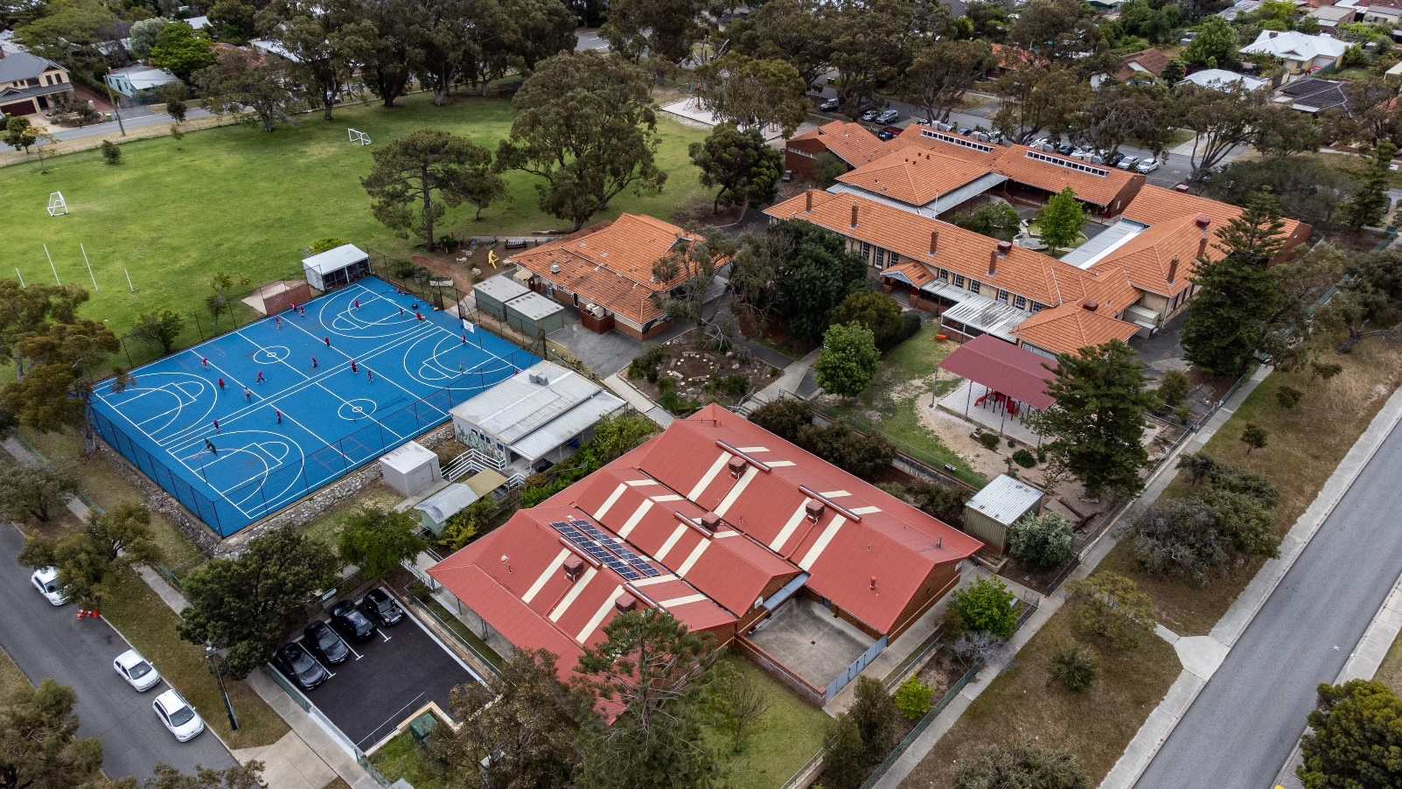

**2023-2025 Business Plan____________________________________** 20

The 2023-2025 Business plan brings together system expectations from the yearly FOCUS documents 2023/4 and 5, Quality teaching Strategy 2023/4, Building on Strength 2024, Reconciliation Action Plan 2023/4, Aboriginal Cultural Standards framework, Equity/Diversity and Inclusion Plan 2021/4 and the Strategic Directions for WA Public Schools 2020-2024: Every Student, Every Classroom, Every Day.

As an Independent Public School, our Business Plan reflects the national agreement for education, the Alice Springs Mparntwe Declaration 2019 outlining the education goals for all Australians across the country.

Our Business Plan outlines and describes the school’s actions and intent in relation to addressing future directions and working towards the school vision.

School improvement is being assessed against our level of effectiveness across six domains. These domains will continue to be addressed through our Board meetings over the three years of the plan. They will provide a view at a point in time on our progress. The domains as they are reviewed are updated culminating to draw a picture after the three years.

These domains reflect those of the department of Education’s external schools’ review process.

**DOMAINS:**

**Relationships and Partnerships-We provide a positive school climate with strong community support. We focus on improved student performance through productive and supportive staff relationships facilitated through our distributed leadership model.**

**Learning Environment**-**We provide and inclusive and welcoming school environment where staff and students feel valued and supported in their work and learning. We promote social and emotional Well-Being support for all our school community.**

**Leadership**-**We develop leadership practices that support excellence, participation and focus creating a culture of shared responsibility to monitor and improve student outcomes and school performance.**

**Use of Resources-We ensure that school resources: human and physical finances, are strategically allocated to support targeted school improvements and maximise student achievements through evidence-based decision making.**

**Quality Teaching-We strengthen our whole school approach to quality teaching with a focus on shared beliefs, purposeful staff collaboration, differentiated quality teaching, engaging lesson delivery and reflective practices using quality data and evidenced based approaches**.

**Student Achievement and Progress- We continue to ensure a regular and accountable cycle of school improvement focusing and fostering excellence in student learning and celebrating student talents and achievements. Through differentiated learning, all students are provided with opportunities to improve and excel.**

We use data and evidence to review our programs and to inform us of the success of changes made to our curriculum programs.

**BUSINESS PLAN ACCOUNTABILITY TRACKER**

Each term the School Board reviews the progress for two of the domains using a document called a Board Accountability Business Plan Tracker.

The Business Plan Tracker has been created to enable us to continuously review our progress against the milestones we have set for the six domains. It identifies who is responsible for the milestone and what data as evidence is needed to be collected and analysed.

By using a traffic light colour coded system, the School Board can easily see what progress has been made as well as being given information pertinent to each milestone.

|  |  |  |  |  |
| --- | --- | --- | --- | --- |
| Indicates no action planned at this time | Indicates no action taken although planned | Indicates milestone not achieved at this time | Indicates in progress | Indicates milestone achieved/maintained |

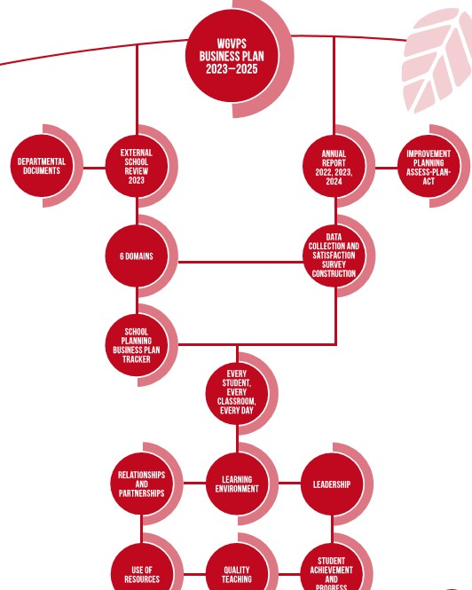

**School Partnerships and School Involvement____________________** 22

Our facilities were accessed by a variety of groups including:

* Fremantle City Council for Precinct Meetings
* Fremantle Tennis Club for before school lessons
* Basketball teams after school
* Music tuition after school
* Horizons before and after school care in one of our buildings
* Playgroup association use of our facilities
* School Chaplain and parent volunteers for Breakfast Club
* Therapists assisting individual students.

Community partnerships included:

* Ed-Connect Volunteer program.
* Foodbank incursion
* Constable Care incursion.
* Spare parts puppet theatre incursion and donation for assembly area from Hawaain.
* Peach Speech Pathology Services and Curtin University providing weekly therapy for several students across the four terms.
* Busy Bees to promote areas of our grounds including the Sensory Garden, Yarning Circle and Centennial Garden.
* Fremantle Council and the use of Booyeembara Park as an outdoor classroom.
* Fremantle City Library.

P&C Association

Our P&C during 2024 raised more than $23000 and generously donated $16,000 back to the school. Thank you to the P&C members, executive and president, Kate Moeller, for their tireless efforts.

The class representatives did a wonderful job sharing the load to distribute information to parents as well as helped with individual year level fundraising activity organisation. The Year 6 committee worked alongside the P&C and through their own fundraising reduced the cost of our annual camp considerably.

A gift to the school of a school tent was a welcome addition to our shade equipment.

In 2024, highlights for students included the disco and movie night.

The P&C Canteen committee and manager/assistant provided excellent menus throughout the year as well as helped with morning tea at our sports day. Many parents as volunteers helped in the canteen during the year.

The Uniform Service representative and volunteers provided an ordering, collection and distribution service during the year. The work to get the uniforms out to students and assist new families was appreciated by the school.

The work of the sub-committees for their endeavours in and around the school was also appreciated. Fundraising activities during the year provided a wonderful social outlet for parents and engaged the students.

The quiz night was a great success, as was the band night, movie evening and coordinating meals for our Open Night, Athletics carnival and Edu-dance evening. Other fundraisers included cake stalls at school, along with Containers for Change and a wine sale.

Funds raised in 2024 were allocated to a range of initiatives to assist with the school program as well as beautify the school grounds. Class allowances, funds for graduation, Year 6 Leavers shirts, lap top computers, Pre-Primary jigsaws, decodable readers, Education by Nature incursion, new school signage, landscaping, FOGO bin service, bus and lane hire for training/entry for the swimming carnival.

The school acknowledged all our volunteers during the year and put together a gift made by the chaplain with students for those who in some way contributed to the running of the school.

The school also undertook writing thank you cards as part of P&C Day celebrations.

School Board

The White Gum Valley Primary School Board was established in 2017 and undertook a Delivery Performance Agreement, Statement of Expectation 2021-2024 and reviewed the 2024 Funding Agreement.

The Board was part of the 2019 and 2023 School Review process.

Our elected Board of five parents and four staff met twice a term in 2024. Meetings were flexible with an online option available.

A yearly calendar of responsibilities was in place to help guide our role. A Principal’s Report and presentation of our budget position was tabled at each meeting.

A Business Plan Tracker was in place for each meeting to review two of the six Domains of the 2023-2025 Business Plan. This tracker provided a focus for members to review data collected for each domain.

Aside from presenting updates and undertaking the business of the Board, staff were invited to address various areas they were responsible for. For each meeting the relevant documents were placed on the Board CONNECT site.

The members are to be congratulated for the role they provide as a skilled and caring group engaged to represent the school community and provide the best for our students. We farewelled Ellie Walker, Kim Felton, Amy Edmonds along with our chair, Russell Nicholls and Megan Bankes, who all completed their tenures. Our appreciation goes out to them for the wonderful contribution that they provided supporting the Board goals.

The Board used a document to guide meetings. It outlined expectations of what needed to be covered for each term and was tabled at the commencement of the year.

Our Board undertook extra training to become familiar with the Board learning modules. Four members also attended professional learning sessions along with members of Boards from other schools.

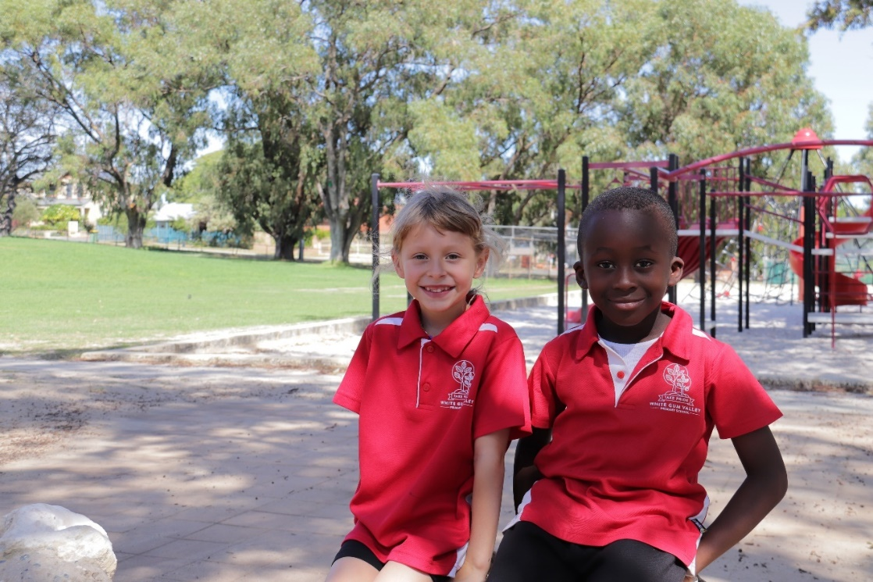

Meetings covered the following content:

|  |  |
| --- | --- |
| **Semester 1** | **Semester 2** |
| Signed off 2024 Funding Agreement  Focus 2024 discussion  P&C and Principal updates  Community use of School Facilities agreements  Code of Conduct 2024.  Budget Reports. Presentation of 2024 Draft Budget  Business Plan Tracker: Coverage of the 6 domains.  Term One testing: Disciplined Dialogue meetings- Individual Education Plans and SSEN planning.  Board module training at each meeting.  Annual Report 2023.  School Entrance statement.  Butterfly Body Bright program.  New whole school programs- Lighthouse Math.  2022/3 School Survey.  Land Care grant application.  NAPLAN results discussion.  Addressing our School Review 2023/4.  Network Conference.  MCS and D/P vacancies.  Gabled structure and sink at Junior block.  Year 6 team building incursion. | Board training modules.  Business Plan tracker domains.  Update on Department Initiatives as part of Focus 2024.  P&C and Principal updates  NAPLAN testing:  School Development Days for 2025 discussion  P&C Day acknowledgment.  Budget reports tabled and discussed.  Operational plans reviewed along with funding requests and budgets.  Draft 2024 budget discussions.  Acknowledgement of parent helpers.  Review of the ‘Out of Hours’ Care service, Tennis coaching and Music tuition.  Early Close application for parent interviews.  School dress code discussion.  Enlarging and enclosing the Covered assembly area.  Voluntary Contributions and Charges for 2025 approval.  School/Hazel Orme Information Booklets.  2025 class structures including Kindergarten provision.  Focus 2025 tabled and discussed.  2025 grants for technology and air conditioning.  Reviewing our Terms of Reference.  QTS grant, building staff capacity.  Network conference.  School shirt design and elder assistance.  School development days for 2025.  RAP discussions.  Parent Math’s workshop. |

Our thanks to the parents and staff who made up the School Board for their valuable input and contributions made during the year. Our appreciation also goes out to the members whose tenures finished during 2024 for the time and energy they put into supporting our school community.

**School Board Chairperson Report**

In 2024, the White Gum Valley Primary School Board had an insightful and productive year, with the School’s commitment to continuous improvement, collaboration and a willingness to embrace new approaches shining through. The Board received updates on the school’s progress across the Business Plan domains in each meeting and the year reflected the commitment to student growth and inclusive learning. The Board extends its thanks to all members for their valuable contributions to a year characterised by partnership, thoughtful governance and perseverance, including building the covered assembly area after many years of planning.

Of particular note was the School’s proactive response to the 2023 School Review. The senior teachers along with the school leadership team demonstrated their enthusiasm and commitment to delivering quality learning at our school. The teachers responded to the Education Department feedback by developing new assessment systems, and ensuring they were workable and embraced by all staff. They established new methods to regularly monitor and respond to the effectiveness of the school’s teaching practices, to continually improve student learning and academic progress.

The School Board was impressed by the level of commitment shown by the School leaders and staff to improve, and it was great to see the hard work and positive approach acknowledged in the Education Department’s 2024 follow up review – *“I have also been made aware of the strong sense of ownership amongst the staff regarding these changes and their determination to continue raising the academic achievements of students… White Gum Valley Primary School is to be congratulated”’*

School staff also shared with the Board the positive leadership training and peer collaboration sessions they had the opportunity to participate in during 2024 which greatly benefited their professional development and our student’s learning experiences. White Gum Valley and Highgate Primary Schools were partnered through the Quality Teaching Program to share teaching methods and initiatives, with both schools gaining many insights from their school visits and information exchange.

Another notable project shared with the School Board in 2024 was the Year 6 teachers and the school’s Aboriginal Education officer initiative to develop a new School Leavers shirt design, led by an Aboriginal Elder working with our Aboriginal students. We are very proud to see the 2025 Year 6 students wearing the new Leavers Shirt and thank everyone involved in creating the artwork and sharing their cultural knowledge.

We also want to thank the teachers and community members who finished working with the School Board in 2024 for their positive involvement and valuable contributions - Kim Felton and Ellie Walker from the school teaching staff, and Megan Banks and Russell Nichols as community and parent representatives.

Teresa Matassa

2025 School Board Chairperson

On behalf of the School Board

**Conclusion_______________________________________________** 25

White Gum Valley Primary School has been an Independent Public School for seven years and as a school community we continue to explore the flexibilities that are available to us to better meet the needs of our students.

Our planning was guided by the Department’s Strategic Plan, FOCUS document 2024 and our 2023-2025 Business Plan along with our Annual Operational Plans across the learning areas.

The school undertakes whole school planning and pedagogical approaches to assist with teaching and learning that will assist with transition from one year to the next. It is actively involved with the ’Teaching for Impact’ which is part of the Quality teaching strategy supported by the education Department. It outlines what effective teachers believe, what they know and what they do to have a high impact on student outcomes.

Our leadership structure has been built through the leadership team and consists of Learning Area, Phase and Curriculum leaders along with input from our auxiliary support staff.

Our leaders also cover the areas of Finance, NQS, Mental Health, STEM, Student Services, Inclusivity, PBS and OHS. Leaders and Teams are represented in Literacy, Numeracy, Science, Health, Arts, Physical Education, HASS and Technologies. A team approach in these Professional Learning Communities across phases of learning has enabled effective Operational Plans to be written and fed into our budgeting processes.

We thank our families who attended our Open Night and interviews scheduled on an early close day. More than, 80% of families were represented during the event.

Congratulations to our students who currently hold the Athletics and Cross-Country shields across our Interschool Competitions and were zone finalists in the cricket event.

With the excellent support of all the school community, our school has continued to provide a teaching and learning program to meet the needs of our students and we endeavour to implement a variety of communication strategies to keep families informed.

We look forward to 2025 using the structure of our 2023-2025 Business plan and the results of our 2023/4 Public School Review to help guide our work and support of staff, families and students.

**We thank you for taking the time to read our 2024 Annual Report.**

For more information, please refer to our school website:

[www.whitegumvalley.wa.edu.au](http://www.whitegumvalley.wa.edu.au)

School Business Plan 2023 – 2025

Reconciliation Action Plan 2024/5

